Kappa Communiqué
Delta Kappa Gamma
Volume 18, Issue 4 Kappa Chapter of Xi State December 2021

The Delta Kappa Gamma Society International promotes professional and
personal growth of women educators and educational excellence.

Upcoming Meeting

Thursday, February 3, 2022
Lakewood School
Buchanan, TN
5 pm

Purpose I: To Unite women educators of the world in a genuine spiritual fellowship.
Purpose VI:. To stimulate the personal and professional growth of members and to encourage their participation in appropriate programs of action.
Program: Learn About Charcuterie Boards
Presenters: Leigh Anne Durham Hostesses: * Kim Denman, Christie Wimberly, Jennifer Cloar, Tammy Carter
Inspiration: Linda Clark
* This hostess receives the RSVP

PRESIDENT’S MESSAGe

Hello Friends!
Can you believe that it is already December? Things are hustling & bustling in my classroom....and I am worn out each night! Christmas time is so fun & magical for preschoolers. I hope in all the craziness of students, or shopping, or to-do lists that you are able to find time to enjoy your loved ones & remember the true Reason for the Season.

Angie Justice

CHAPTER WEBPAGE
http://kappachaptertn.weebly.com/

LEGISLATIVE NEWS

FORUM FACEBOOK PAGE LINK
For those of you desiring discussion of legislative topics there is a U. S. Forum Facebook page online at http://www.facebook.com/DKG.US.Forum
FORUM WEB SITE: http://www.usforumdkg.org/

Dates to Remember

Forms and applications are available at: http://www.xistate.org/
Date: December 12, 2021
Arts and Personal Growth
The Arts and Personal Enrichment Committee is hosting an event at the Cumberland County Playhouse in Crossville on Sunday, December 12 at 3:30 p.m. EST/2:30 p.m. CST for Scrooge, the Musical. Members will have an opportunity to spend a fun afternoon together.
Due Date: December 31, 2021
Vision Foundation
Liz Whorley Bradley Professional Growth Award and Project Grants: Please consider filling out an application to attend a seminar, workshop, or professional meeting or to conduct educational research and/or develop special projects for your classroom. Applications and guidelines for Project Grants and the Liz Whorley Bradley Professional Growth Award (attached) are also found on the TNSO website under Vision Foundation/Guidelines/Applications or Resources/Scholarships & Grants. Up to $2000.00 is given to the winner of the Liz Whorley Bradley Professional Growth Award and up to $1000.00 is given to each winner of a Project Grant. Applications are due no later than December 31, 2021. Applications may be submitted to Dr. Cathy Meredith, cdmeredith18@gmail.com.
Essay Contest
The 2021 – 2022 Tennessee State Organization Essay Contest topic will focus on the pandemic we have and are experiencing. We know the hardships that each of us have encountered in our lives, but we want to hear what teenagers have to say on this topic. Select a middle school and/or a high school in your area. Provide teachers with the topic, rules, and forms provided. Ask them to encourage students to enter our contest. February 25, 2022 will be the deadline for submitting an entry.
Legislation
The Legislative Committee is planning the 2022 Legislative Symposium and the Day on the Hill. Next year’s events will be divided into three components:
1. Approximately two to three weeks prior to our Day on the Hill, we will again offer a Virtual Symposium, consisting of a panel of legislators, local and state representatives and a keynote speaker, TBD. This event will be available to all DKG TN members.
2. One week before the Day on the Hill, the Legislative Committee will host a virtual workshop, or “Prep Rally”. This workshop will inform members on legislative contacts, proposed bills concerned with education and review procedures for the Day on the Hill.
3. The Tennessee State Organization looks forward to our Days on the Hill.
Dates for the Legislative Symposium, “Prep Rally” and Day on the Hill will be available in early December. Please contact Amber Roberts (ahroberts@ortn.edu ) for further information.
The Legislative Committee is offering the Legislative Award for the 2021-2022 year. The form is attached and found on the state website Resources/Chapter Forms & Reports. Deadline for submission is March 15, 2022, ahroberts@ortn.edu .

More Dates to Remember

- 86th Tennessee State Convention 2022—Sewanee, Tennessee—June 2-4, 2022
- International Convention 2022—New Orleans, Louisiana—July 12-16, 2022
- DKG Ignite (LMS) Application due December 15, 2021.

Member News
ROSES

Lynn Cole and Leigh Anne Durham were selected for the Tennessee Rural Stem Collaborative from the Tennessee Stem Innovative Network (TSIN).

This is a yearlong cohort with hands on planning, a stipend, and money for their chosen projects. Pam Pettyjohn and Heather Sneed were also chosen.

Left to right: Leigh Anne Durham, Pam Pettyjohn, Heather Sneed, and Lynn Cole.

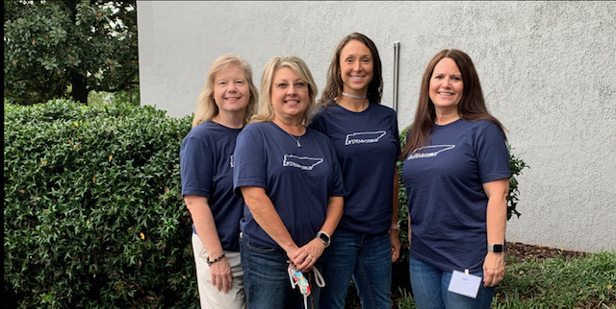

Denise Baker’s daughter Rachel and Christopher Richard were married on November 21.

Jeanette Brandon and Jerry celebrated their 51st wedding anniversary in November.

Tammy Carter Ran in the St. Jude Marathon and raised $1,640 for the hospital.

Jenny Cooper and her dad (Renee’ Cooper’s husband) also ran in the St. Jude Marathon.

Amy Davis is celebrating having a high school senior as her daughter. Karlie just signed with Union University to play volleyball next year! Such an exciting year for both!

Olivia Fowler has a new puppy. Ask to see her pictures.

Rachel Hollowell has a sweet new baby boy. Welcome Arlie Leon.

Angie Justice celebrated her 24th wedding anniversary.

Emily Knight completed a 50-mile challenge for St. Jude’s Research Hospital.

Amanda Medlin celebrated her 23rd wedding anniversary in October.

Jenny Miller is looking forward to a visit from her son from Dhabi and his family in the month of December. They plan to stay in the states for a whole month.

Merry Christmas to all and a healthy New Year!

