Kappa Communiqué
Delta Kappa Gamma
Volume 16, Issue 3 Kappa Chapter of Xi State October 2019

The Delta Kappa Gamma Society International promotes professional and
personal growth of women educators and educational excellence.

Upcoming Meeting

November 7, 2019
5:00
Program: Bunko
Presenter: Lisa Bell
Location: Briarwood School, Room 317, Camden
Inspiration: Lori Cantrell
Hostesses:
Amy Davis*
amy.davis@bcos.org,
Jenny Miller
Lori Cantrell
Tina Arnold
Traci Eason
* This hostess receives the RSVP.

PRESIDENT’S MESSAGe

Ladies,
Fall is in the air. I’m so excited about the cooler weather. I am also excited about our upcoming meeting. Please be thinking of potential members and invite them to this fellowship time. Just let your hostess know if you are bringing guests. This is a great way for ladies to see who we are and for what we stand.

I look forward to seeing everyone at our final meeting for this year.
Lynn

Dates to Remember

Members are encouraged to bring a friend (they do not have to be educators) to our November meeting. This meeting is our fundraiser for the year and the $10.00 fee per person will be collected and sent to educational projects we support.

The November meeting is our chapter book sale. If you have gently used books, videos, dvds, or audio books you want to contribute box them up. Also, we give children’s books to local offices for their reception areas. Bring books you want to donate as well.

Our chapter will not meet in the month of December. Programs for 2020 will be sent out in the December newsletter.

TN State forms and applications are available at: http://www.xistate.org/
20
June 4-6, 2020 is the date for our 85th Tennessee State Organization Convention. We will meet at Sewanee: The University of the South for our 2020 convention.

The 2020 International Convention will be held July 7-11, 2020 at the Philadelphia Marriott Downtown.

International Deadlines
International Leadership Management (DKG Ignite) application and video due December 1, 2019.

Member News
ROSES

Emily Pierce’s daughter Kay has been accepted at the University of Tennessee in the Engineering program. Her other daughter Emma is running in the middle school cross country state championship race in Knoxville.

Benton County received a 1.58 million dollar reading improvement grant from the state of Tennessee.

Betty Jordan is changing positions in January. She will be known at the Oprah of Benton County.

Crystal Nelson’s son Paul is responding well to potty training

Emily Knight is expecting a baby girl!

Member News
THORNS

Our sympathies to Susan Woods who lost her life-long companion Bob this month. Susan has been his primary caregiver for many years.

Jenny Miller lives in the storm damage area in Decatur County. It is predicted to be three weeks before electricity is restored to her area.

Holladay School has no running water and will be closed until power is restored to the pumping plant.

Remember Dr. Joyce and her husband Larry as well as Lisa Bell and her sister.

CHAPTER WEBPAGE
http://kappachaptertn.weebly.com/

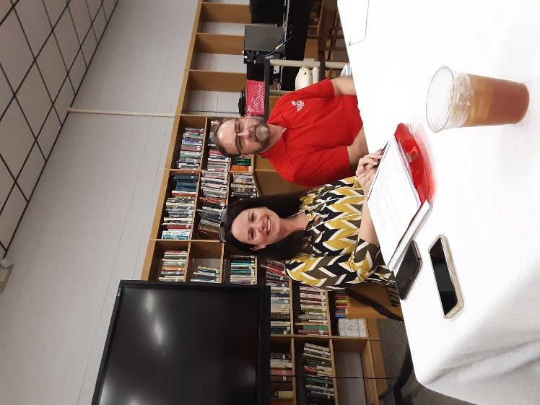

October Program

On Thursday, October 3, 2019 members of Kappa Chapter were welcomed by Lynn Cole, president. She introduced our guest speaker, Dr. Randy Shannon, director of the Senator Frank P. Lashlee Career and Technical Center. Dr. Shannon is also a lawyer and a mediator for the Tennessee Supreme Court.

Dr. Shannon spoke from a slide presentation titled: Trauma: A Growing Trend in Education. Dr. Shannon concluded his presentation by encouraging the group to keep healthy by taking personal time for self, exercising, eating healthy, and getting enough rest. More information may be found at Dr. Brenda Ingram’s website:

https://traumainformedla.org/who-we-are/steering-committee/brenda-ingram/

The program concluded with Jeanette Brandon thanking Dr. Shannon for his time and presenting him with a gift.

Founders day update

The committee has reserved the venue and found accommodations for our out of town guests at our 80th Founders Day anniversary in May of 2020.

