Kappa Communiqué
Delta Kappa Gamma
Volume 15, Issue 3 Kappa Chapter of Xi State November 2018

The Delta Kappa Gamma Society International promotes professional and
personal growth of women educators and educational excellence.

Upcoming Meeting

Thursday, February 7, 2019
Where: Lakewood Elementary School
Paris, TN
5:00

Purpose I: To unite women educators of the world in a genuine spiritual fellowship.

Purpose VI: To stimulate the personal and professional growth of members and to encourage their participation in appropriate programs of action.
Program: Taking Care of Me
Presenter: -Teresa Paschal

Hostesses: * Leigh Anne Durham
Durham89@bellsouth.net
Linda Clark, Jenny Cooper, Shirley Braden, and Mary Johnson
* This hostess receives the RSVP

Inspiration: Linda Clark

PRESIDENT’S MESSAGe
Ladies,

I believe that fall weather is over. I hope everyone enjoyed their surprise SNOW DAY! We had a super fun time Painting with a Purpose.
I look forward to seeing everyone on Thursday, February 7, 2019 @ Lakewood School for our next meeting entitled "Taking Care of Me.”
Please email me names of potential members by Friday, January 4th, so that we can get biographical information out to members before our February meeting. I hope everyone has a WONDERFUL Thanksgiving!
Love to you all!
Lynn

Legislative News
Lynn Cole and Jenny Miller will be attending at Tennessee Education Association meeting on Saturday, December 1st. Important information about expected changes for legislation will be shared in the next newsletter.
Our Commissioner of Education is leaving to pursue a job in the private sector. A new Governor and new State Representatives in the Assembly give us opportunities to develop relationships which may impact funding, laws, and policies affecting every classroom in our state.

Member News
Congratulations
- Kim Denman’s son, Nelson is being inducted into National Honor Society on November, 18th. Her daughter, Braden Clare made the All-Northwest Honor Choir for the 3rd year in a row. Special concert held in Jackson on November 17th.
- Autumn Ratliff has been elected Mayor of Big Sandy, TN!
- Mary Lou Marks has been enjoying a visit with her Canadian grandbabies.
- Lori Cantrell’s son Spencer was ordained on November 17.
- Pam Myrick’s daughter Amelia was 1st maid in the Camden Lions pageant.
- Susan Woods completed the Fiery Gizzard loop trail (strenuous hike)
- From Dr. Joyce:
I’m excited to be going to visit my daughter and son-in-law over Thanksgiving. They live in West Linn, OR. My daughter, the great planner, already has every day planned out. We’ll be baking cookies, going shopping, going to the Oregon Zoo for Christmas ‘Zoo Lights’, we already have tickets to see Fantastic Beasts, we have reservations at a nice restaurant for Thanksgiving day. We’ll be hitting Target to get towels on sale, and my daughter invites friends over for midnight Thanksgiving (This tradition started when most of them worked at Target and only got of late at night). This year it will be on the Friday after Thanksgiving at 10pm. Decorations and menu are already set of course. We are all wearing costumes from a fairy tale. They usually do a group picture, but this time, individual pictures will be taken and Natalie will work her photograph magic to make it a ‘group’ picture. On Saturday we are going to go cut down their Christmas tree and that night we’ll see the Festival of Lights at the Grotto:
https://thegrotto.org/christmas-festival-of-lights/.
Sunday we decorate the tree and we have tickets to a Blazers basketball game. I’ll get to see Natalie’s artwork in the gallery and perhaps do more shopping of course!
Larry has been fortunate enough to get a two week break from treatment so he can enjoy Thanksgiving, most likely spent with his brother while I’m gone. He makes it day to day and after each treatment the side effects get a little worse. He’ll finish up chemo sometime in January.
I wish everyone a Happy Turkey day and thanks for keeping both of us in your thoughts and prayers.

Member News
Concerns

- Remember Dr. Joyce & her husband
- Lisa Bell & her sister
- Jeanette Brandon’s son Chad
- Amy Davis’ lost her Aunt Ruthie
- Sympathies to former Kappa Chapter member Paula Cox on the loss of her beautiful daughter Megan

CHAPTER WEBPAGE
Our chapter webpage is located at:
http://kappachaptertn.weebly.com/
Most information can be found here if you don’t have your yearbook handy.
XI State Arts Retreat 2018
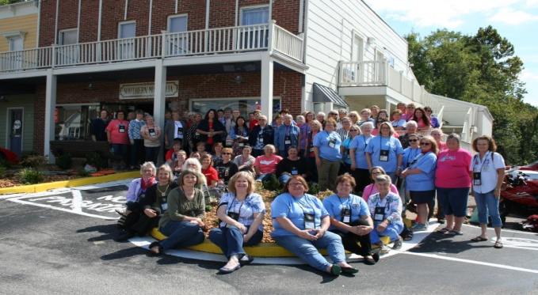
Dates to Remember
Forms and applications are available at: http://www.xistate.org/
Date for 2019 Xi State Convention
May 30, May 31, and June 1. Add these dates to your calendar and make plans to attend.

